
CEMP – Centro Educacional Marapendi
Nome: ______________________________________________ Data: / /2024
Professor(a): 6 º Ano do Ensino Fundamental II Turma: _____
TRABALHO DE PESQUISA - LÍNGUA PORTUGUESA 2º Bimestre valor: 2,0

PARTE I
ESTA É A HISTÓRIA DO MEU NOME:

1- QUEM ESCOLHEU SEU NOME? POR QUÊ?
________________________________________________________________________________________________________________________________________________________________________________________________________________________________________________________________________________________________________________________________________________________________________________________________________________________________________________________________________________________________________________________________________________________________________________________________________________________________________________________________________________________________________________________________________________________________________________________________________________________
PARTE II
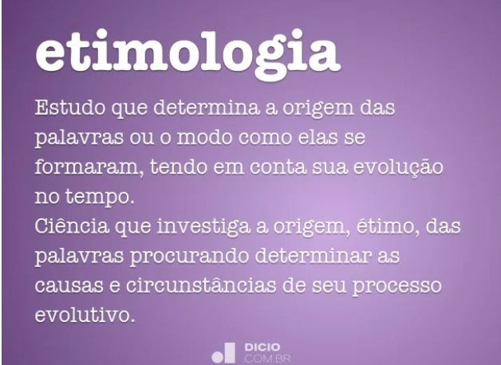

2- QUAL A ETIMOLOGIA (ORIGEM) DO SEU NOME?

________________________________________________________________________________________________________________________________________________________________________________________________________________________________________________________________________________________________________________________________________________________________________________________________________________________________________________________________________________________________________________________________________________________________________________________________________________________________________________________________________________________________________________________________________________________________________________________________________________________

3- QUAL O SEU SIGNIFICADO?
________________________________________________________________________________________________________________________________________________________________________________________________________________________________________________________________________________________________________________________________________________________________________________________________________________________________________________________________________________________________________________________________________________________________________________________________________________________________________________________________________________________________________________________________________________________________________________________________________________________

4-QUAIS AS VARIAÇÕES ENCONTRADAS DO MESMO NOME?
(Ex: Juliana, Julliana, Juliane, Juliene,etc.)
________________________________________________________________________________________________________________________________________________________________________________________________________________________________________________________________________________________________________________________________________________________________________________________________________________________________________________________________________________________________________________________________________________________________________________________________________________________________________________________________________________________________________________________________________________________________________________________________________________________

5- ESSAS VARIAÇÕES CAUSAM ALTERAÇÃO NA PRONÚNCIA? EXEMPLIFIQUE:
(Ex: Raisa=som de Z
Raissa= som de S)

________________________________________________________________________________________________________________________________________________________________________________________________________________________________________________________________________________________________________________________________________________________________________________________________________________________________________________________________________________________________________________________________________________________________________________________________________________________________________________________________________________________________________________________________________________________________________________________________________________________

6-HÁ ALGUM FAMOSO COM O NOME IGUAL AO SEU? QUAL A PROFISSÃO DELE (A) ?
________________________________________________________________________________________________________________________________________________________________________________________________________________________________________________________________________________________________________________________________________________________________________________________________________________________________________________________________________________________________________________________________________________________________________________________________________________________________________________________________________________________________________________________________________________________________________________________________________________________

CRITÉRIOS DE AVALIAÇÃO | TOTAL:
Ortografia 0,5

Criatividade 0,5

Organização 0,5

Coerência 0,5

