# CEMP - Centro Educacional Marapendi

**Nome: ______________________________________________ Data: / /2025**

**Professor(a): Gabriela Nogueira 7o Ano do Ensino Fundamental II Turma: _____**

**QUESTIONÁRIO 1 DE GEOGRAFIA PARA O TESTE DE GEOGRAFIA 2º Bimestre**

1) “O avanço da atividade industrial desencadeou grandes mudanças, tanto no espaço rural como no espaço urbano”.

Nesta relação entre o campo e a cidade cada um se especializou e fornecer e comprar um produto. Desta forma, preencha as colunas abaixo com os produtos que são vendidos e os produtos que são comprados.

**Campo**

**________________________________________________________________________________________________**

**Empregado no campo para aumentar a produtividade e no abastecimento da população.**

**Cidade**

**Empregado na indústria como fonte de matéria prima e no abastecimento da população.**

**_______________________________________________________________________________________________**

2) Denomine e caracterize os tipos de agricultura abaixo.

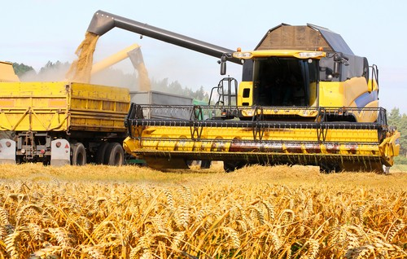

________________________________________________

_______________________________________________________________________________________________________________________________________________________________________________________________________________________________________________________________________________________________________________________________________________________________________________________________________________________________________________________

________________________________________________

_______________________________________________________________________________________________________________________________________________________________________________________________________________________________________________________________________________________________________________________________________________________________________________________________________________________________________________________

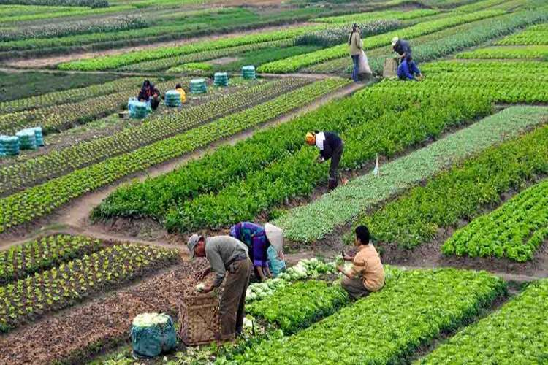

3) Observe as fotos e responda.

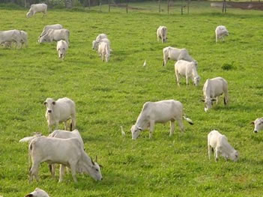

**1**

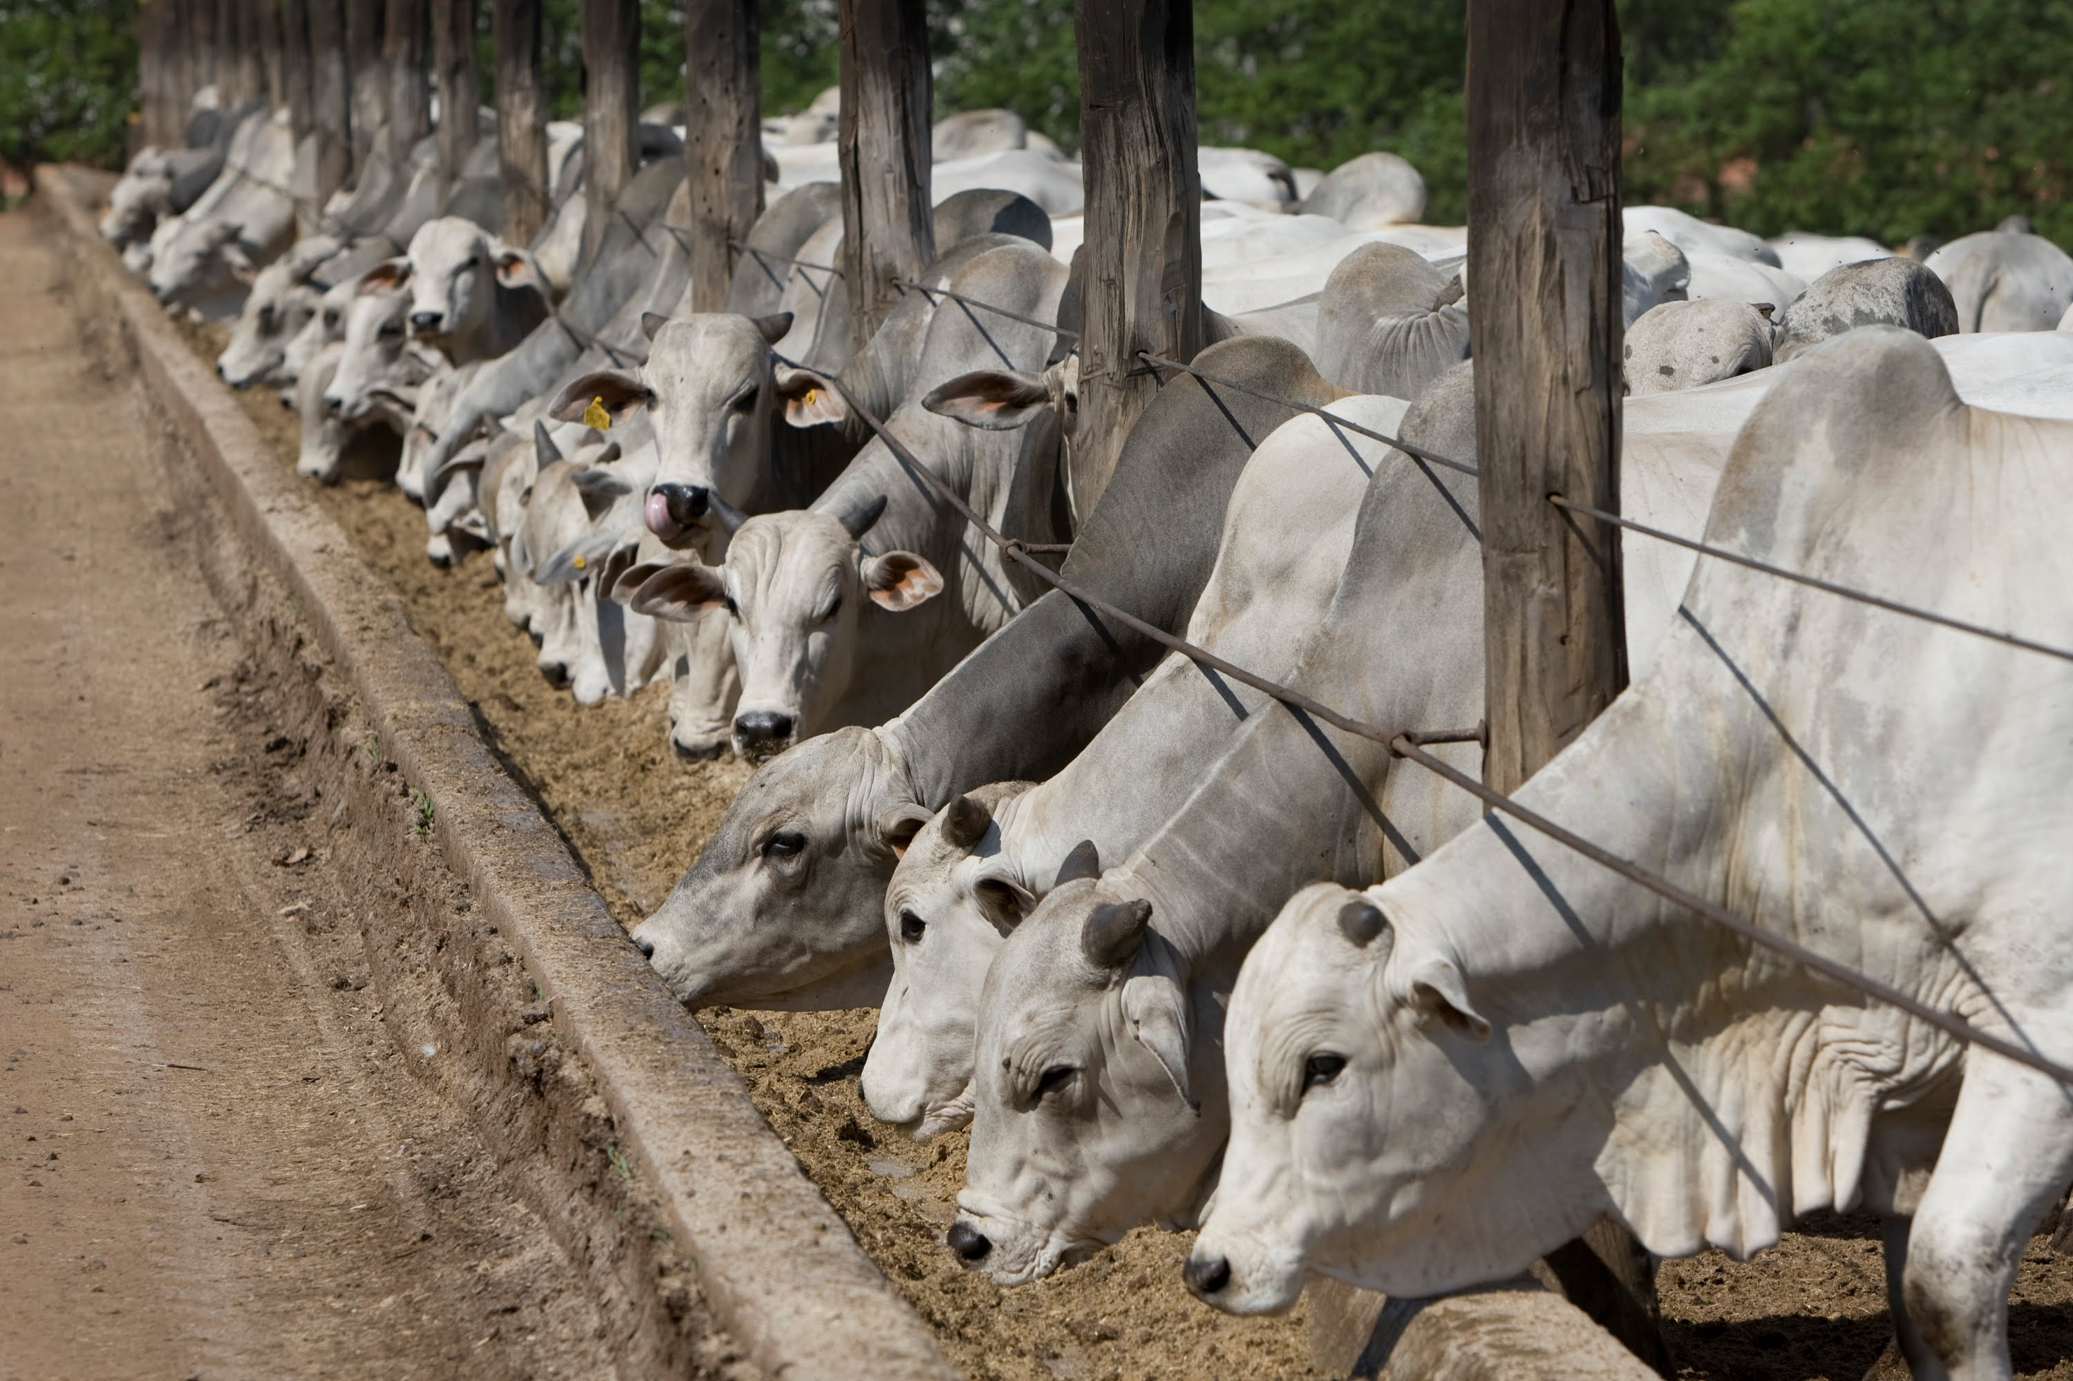

**2**

a) Quais são os tipos de pecuária retratados nas fotos ?

________________________________________________________________________________________________________________________________________________________________________________________________

b) Quais são as principais características do tipo de pecuária retratado na foto 1?

________________________________________________________________________________________________________________________________________________________________________________________________________________________________________________________________________________________________________________________________________________________________________________________________________________________________________________________________________________________________

c) Quais são as principais características do tipo de pecuária retratado na foto 2?

________________________________________________________________________________________________________________________________________________________________________________________________________________________________________________________________________________________________________________________________________________________________________________________________________________________________________________________________________________________________