# CEMP – Centro Educacional Marapendi



**Nome: ______________________________________________ Data: / /2025**

**Professor(a): ELIANE 9o Ano do Ensino Fundamental II Turma: _____**

**INGLÊS**

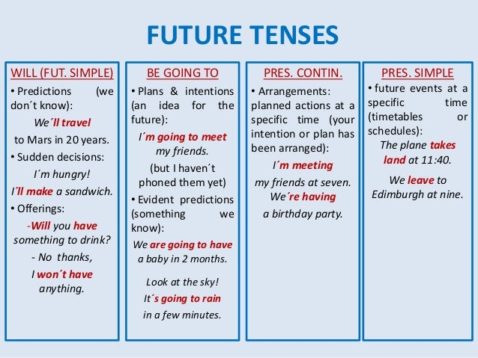

1. Watch this video.

<https://www.youtube.com/watch?v=qAiZ2YdjaeQ>

Quiz exercise.

<https://www.youtube.com/watch?v=9vwQZQNWBK8> 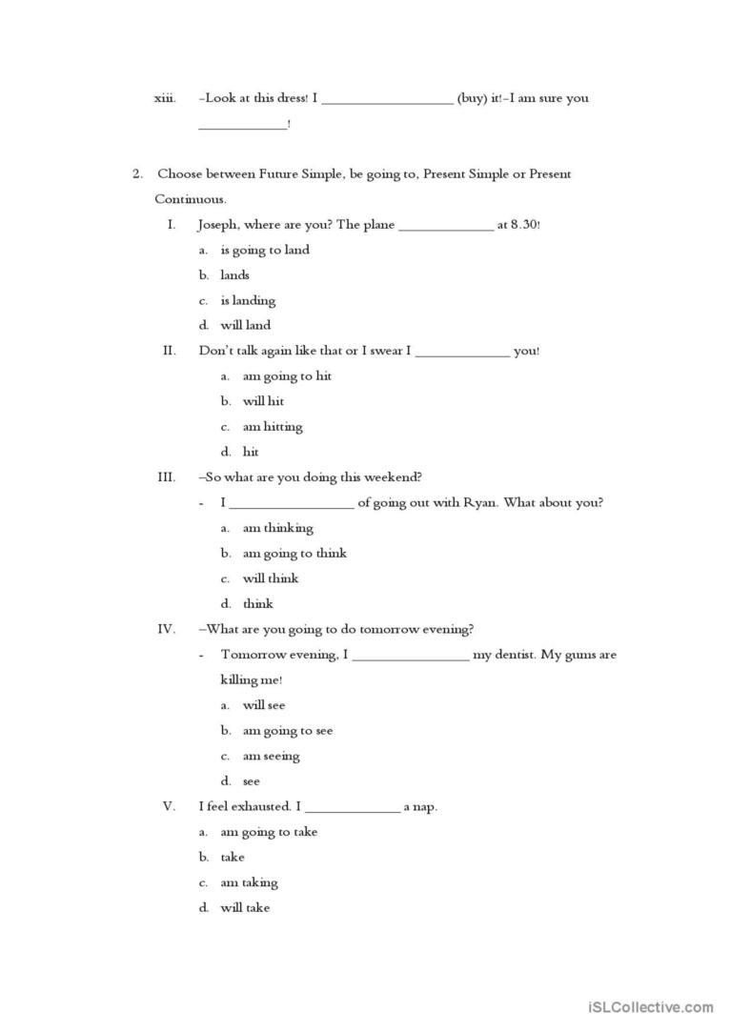



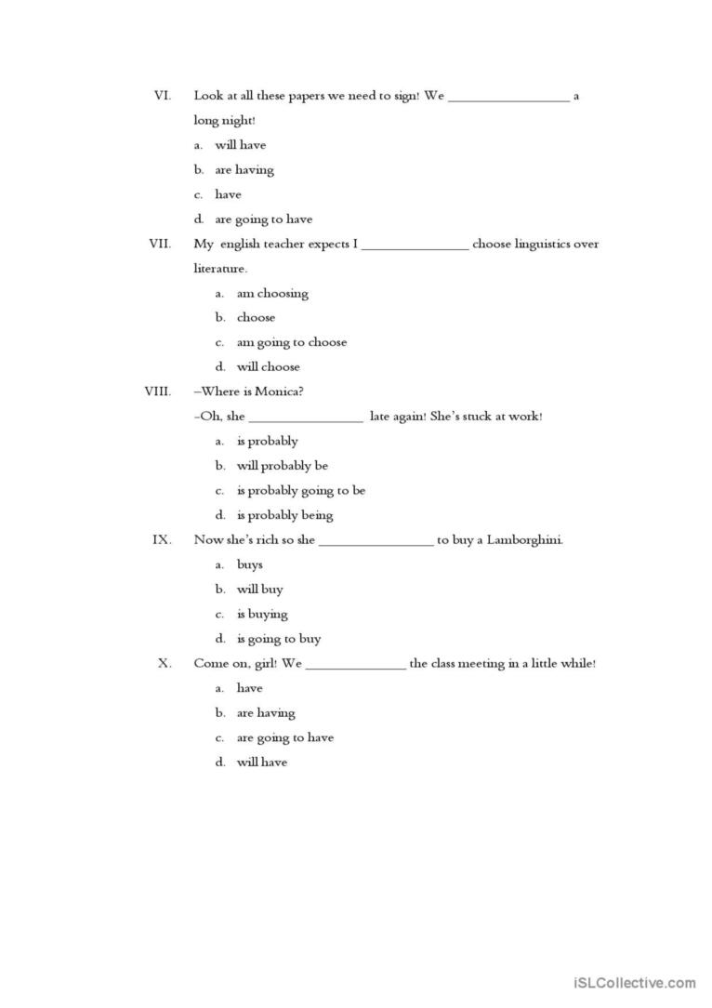

**FUTURE CONTINUOUS**

