CEMP – Centro Educacional Marapendi

Nome: ______________________________________________ Data: _____/______/ 2025
Professora: LUISE 9º Ano do Ensino Fundamental II Turma: 9º A e B
Gabarito dos exercícios do workbook Unit 6.

WB pg 46,
Exercise 1.
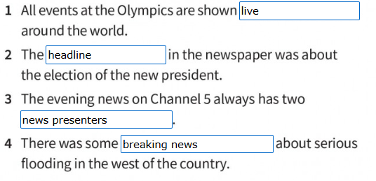

Exercise 2
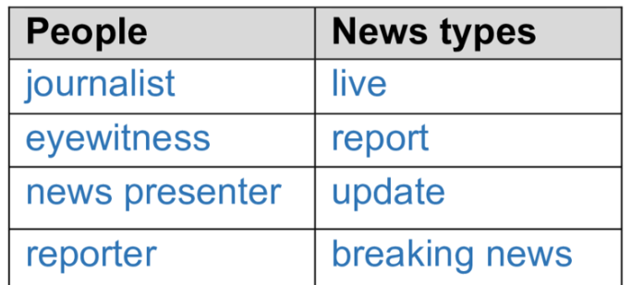

Exercise 3.
1-news presenter
2-reports
3-headlines
4-reporters
5-eyewitness
6-breaking news
7-live
8-update

Pg 47.
Exercise 5
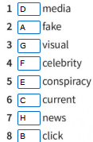

Exercise 6.
2-platform 6-newsfeed
3-correct 7-influencers
4-medium 8-correct
5-correct

Exercise 8.
1-delighted
2-weird
3-friendly
4-easy
5-different
6-unlikely

Pg 48.
Exercise 1
1-A
2-B
3-B
4-B
5-B
6-A
Exercise 2.
1-A
2-B
3-B
4-C
5-B
6-A

Exercise 3
1-was 2-felt 3-had been looking 4-was enjoying 5-had found 6- couldn´t believe

Exercise 4
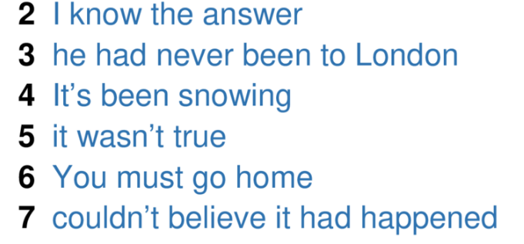

Pg 49.
Exercise 5
1-B
2-A
3-A
4-B
5-A
6-B
7-A

Exercise 6
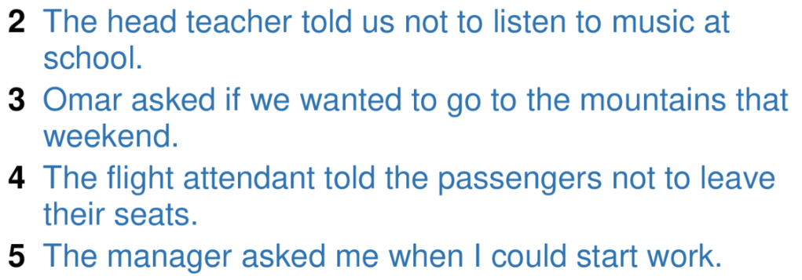

Exercise 7

2-Could talk
3-Me to look
4-I enjoyed
5- I felt

Exercise 8

2-Had
3-Told
4-If
5-To
6-Not
7-What

