CEMP – Centro Educacional Marapendi


Nome: ______________________________________________ Data: _____/______/2025
Professor(a): _____________________ 6º Ano do Ensino Fundamental II Turma: A/B/C
REVISÃO DE INGLÊS

Past Simple: affirmative and negative , regular and irregular verbs
Read the examples below:
•They watch TV every evening. (present)
•They watched TV yesterday evening (past)
Watched is the past simple:
I / we / you / they watched.
He / she / it watched.
AFFIRMATIVE
We usually make positive (affirmative statements) by adding '-ed' to the infinitive. For example, 'play' becomes 'played'.
Examples :
• I clean my teeth every morning. This morning I cleaned my teeth.
•Tim worked in a bank from 2005 to 2011.
•Yesterday it rained all morning. It stopped at lunchtime.
•We enjoyed the party last night .We danced a lot and talked to a lot of people. The party finished at midnight.

Other verbs
work -> worked stay -> stayed
clean -> cleaned need -> needed
start -> started play -> played
dance -> danced visit -> visited

ATTENTION
Some verbs are irregular (= not regular). The simple past is not -ed. Here are some important irregular verbs.

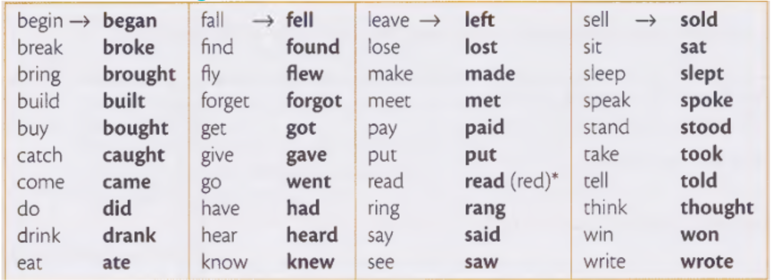

Examples:
• I usually get up early, but this morning I got up at 10 o’clock.
• We did a lot of work yesterday.
• Olivia went to the cinema three times last week.
• James came into the room, took off his coat and sat down.
NEGATIVE AND QUESTIONS
• We use DID in the past simple negative and questions.
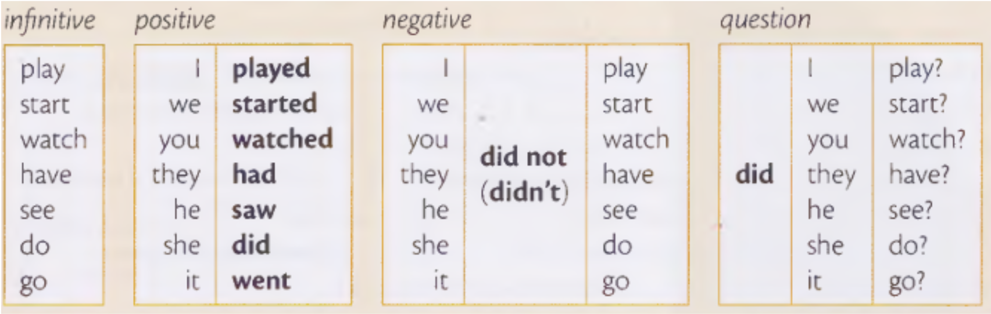

Do / does ( present ) -> DID (past)
Examples:

• I don’t watch TV very often. (present)
• I didn’t watch TV yesterday. (past)
• Does he often go to the gym? (present)
• Did he go to the gym last week? (past)

ATTENTION
- When we use the auxiliary did (in questions or negatives), the main verb stays in the base form (we don’t change it to the past form).
Examples:
- I played football with my team yesterday, but we didn’t win.
- ‘Did you do the shopping?’ ‘No, I didn’t have time.’
- I went to the cinema, but I didn’t enjoy the film.

- The word order in questions is also important. Always read the sentences carefully!
Word order for questions: Did + subject + infinitive
Examples:
• Did your brother call you?
• Did you see Alissa yesterday ?
• Did you like the concert ?

ATTENTION
Question words should come BEFORE the auxiliary ‘did’ in a question.
Read the second possibility of the word order in questions and the examples.
QUESTION WORD (WHEN, WHAT, HOW, WHERE...) + did + subject + infinitive
Examples:
• What did you do last night?
• How did the accident happen?
• Where did your friends go for their holiday?
Short answers
• Yes, I/ we / you / they did .
Yes, he / she / it did.
• No, I / we / you / they didn’t .
No, he / she / it didn’t.
Examples:
• ‘Did you see Claire yesterday?’ ‘No, I didn’t.’
• ‘Did it rain on Friday? ‘Yes, it did.’
• ‘Did Joshua come to the party?’ ‘No, he didn’t.’

