CEMP – Centro Educacional Marapendi


Nome: ______________________________________________ Data: _____/______/2025
Professor(a): _____________________ 7º Ano do Ensino Fundamental II Turma: A/B
REVISÃO DE INGLÊS

Should and shouldn’t

We use ‘should’ or ‘shouldn’t’ to give or ask for advice, to make recommendations, or to express what we think is right or wrong.

You should do something = it is a good thing to do, it is the right thing to do.

Examples :

- Should I invite Carol to the cinema? (asking for advice)
- It is a good film. You should go and see it. (making a recommendation)
- Tom doesn’t study enough. He should study harder. (giving advice)
- You shouldn’t lie to your friends. (expressing what is right or wrong)

You shouldn’t do something = it is not a good thing to do.

ATTENTION

Shouldn’t = should not

Examples:

- Susan shouldn’t go to bed so late.
- You watch TV all the time. You shouldn’t watch TV so much.

To form yes / no questions, we change the order of the subject and ‘should’.

Example:

- Should I go now?

Yes, you should.
No, you shouldn’t.

- We can also form questions with a question word.
Example:

- What should we wear to the party tonight?

ATTENTION

We use an infinitive without to after should and shouldn’t.

Example : You should read more books.
Must and Mustn’t
We use must to express necessity, obligation, rules, or a strong recommendation.
I must (do something) = I need to do it.
Examples:
- It’s a fantastic film. You must see it. (strong recommendation)
- You must do your homework. (obligation)
- The windows are very dirty. We must clean them. (necessity – cleaning the windows is necessary.)
- Your suitcase must weigh less than 23 kilos. (rule – must be followed)

We use must not (mustn’t) to express prohibition or to indicate that something is against the rules.
I must not (mustn’t) do something = it is necessary not to do it; it is the wrong thing to do.
Examples:
- You mustn’t smoke in the building. (prohibition)
- Students must not use mobile phones in class. (it’s against the rules)

ATTENTION
- The form must is the same for every subject (I, you, he, she, it, we, they).
- We use an infinitive without to after must.

Have(got) to + infinitive without to

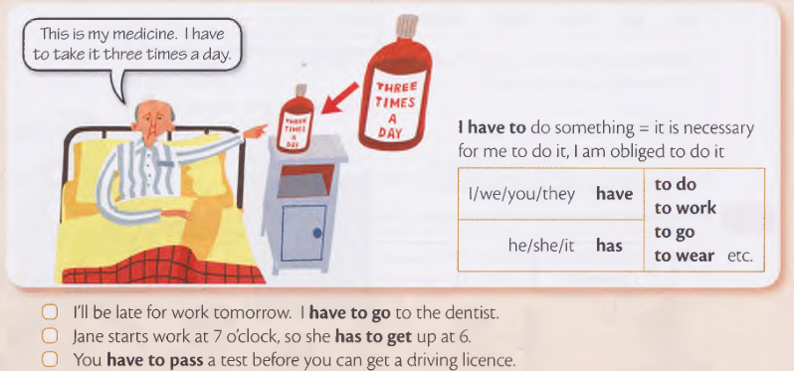

We use have to or have got to to talk about obligations or necessity.
We use don’t / doesn’t have to or haven’t / hasn’t got to when something isn’t necessary (there is a choice).

Examples:

I’m not working tomorrow, so I don’t have to get up early.

Ian doesn’t have to work very hard. He’s got an easy job.

Attention:

We don’t use short forms with have to:

I’ve to call my dad. X

I have to call my dad. ✓

But we can use short forms with have got to:

I’ve got to call my dad. ✓
- To form questions with have to, we use DO / DOES.

Structure:

DO / DOES + SUBJECT + HAVE TO + INFINITIVE WITHOUT TO + ?

Example:

- Does he have to do this exercise?
- To form questions with have got to , we use HAVE / HAS.

Structure:

HAVE / HAS + SUBJECT + GOT TO + INFINITIVE WITHOUT TO + ?

Example:

- Have we got to leave now?

ATTENTION:

We often give short answers to questions with have to or have got to.

Examples:

- ‘Do I have to go to school tomorrow?’ ‘No, you don’t.’

- ‘Has she got to wait for them?’ ‘Yes, she has.’

