CEMP – Centro Educacional Marapendi


Nota:

_______

Nome: ______________________________________________ Data: / /2026
Professor(a): Vinícius 7 º Ano do Ensino Fundamental II Turma: _____
GABARITO DA PROVA DE INGLÊS - 1º TRIMESTRE (10,0 pontos)

- Match the words to their corresponding images.

dance | photography | music | sculpture

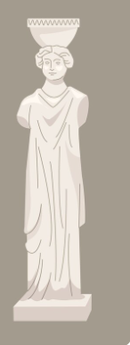

dance sculpture

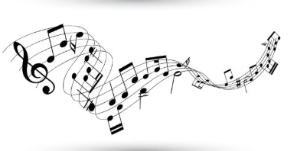
photography music

- Match the words to their synonyms.

a huge ( b ) beautiful
b pretty ( a ) enormous
c awkward ( c ) weird
d colorful ( d ) brilliant

- Choose the correct option.

a. Were you studying yesterday ?
( X ) Yes, I have a test tomorrow.
( ) Yes, we met! We had an awesome meal.

b. Was your brother playing?
( ) No, they were at home with me.
( X ) No, he is not in the band anymore.

c. I saw you at the park. Who were you talking to?
( X ) We were with our classmates. We were talking about the test.
( ) My dentist was busy. She couldn’t see me at the time I scheduled.

d. Remember your birthday party? The smell was great in the kitchen! What is ot your brother cooking?
( X ) Oh no! He can’t cook.
( ) He drove me to school.

- Match the verbs to their Simple Past form.

- Catch | ( d ) Had
- Become | ( c ) Did
- Do | ( b ) Became
- Have | ( a ) Caught

- Write the Negative form of the verbs below.

- Vicenzo stole the painting.
Vicenzo didn’t steal the painting.

- Newspapers reported the crime.
Newspaper didn’t report the crime.

- He planned the crime days before.
He didn’t plan the crime days before.

- He confessed the crime to the police.
He didn’t confess the crime to the police.

- Odd one out. Which word is not part of the group?
- playground skatepark school
- café restaurant music
- open-air theater outdoor picnic library
- lake pond soccer

- Name the outdoor activities below.

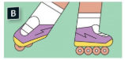

Free-running in-line skating

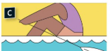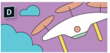
Rowing Drone flying

- Make up questions.
- Where did you go?
I went to school.

- How did they come?
They came by train.

- What did you give to the librarian?
I gave the book to the librarian.

- When did your mom drive you to school?
My mom drove me to school yesterday.

- Organize the words to make sentences.
- Opened / window / the / I / .
I opened the window.

- Closed / door / the / you / .
You closed the door.
- Music / We / to / listened / .
We listened to music

- TV / they / watched / .
They watched TV.

- Circle the bridge, the playground and the lake.

BRIDGE = PONTE
PLAYGROUND = PARQUE
LAKE = LAGO

