CEMP – Centro Educacional Marapendi


Nome: ______________________________________________ Data: / /2026
Professor(a): Isabelle 9 º Ano do Ensino Fundamental II Turma: A/B
ATIVIDADES DE INGLÊS - TRABALHO - 2º TRIMESTRE

Opinion essay preparation - Unit 4
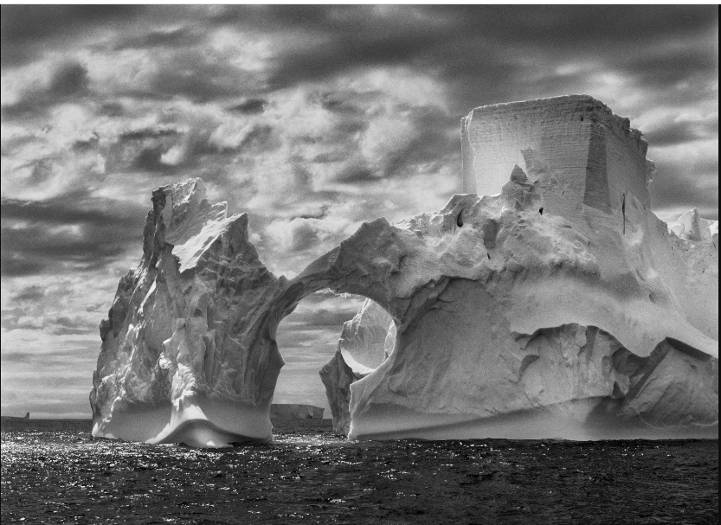

Write an opinion essay based on questions the photo “ Iceberg between Paulet Island and the South Shetland Islands on the Antarctic Channel” may raise.

Here are some inquiries you may use as a theme:
- Is it still possible for humans to live in balance with nature?
- Should untouched natural areas be protected from human activities?
- Can photography help change people's attitudes toward the environment?
Here are some points that may help you describe the photograph:
- the immense size of the iceberg,
- the absence of human presence,
- the feeling of beauty, power, or fragility,
- the contrast between nature and human intervention.
Follow the following structure to write an opinion essay with 14 to 20 lines:

Paragraph 1- present your argument (Introduce the topic and give your opinion)
P.2- Describe the main idea
P.3- Give convincing opposite opinion
P.4- Conclusion - Repeat the main idea and reinforce your opinion.

Chosen theme: Can photography help change people's attitudes toward the environment?
Example 1:
P.1
This opinion article is based on Sebastiao Salgado’s photo, “Iceberg between Paulet Island and the South Shetland Islands on the Antarctic Channel”. This piece shows a remote and cold place, exposing nature’s power and the natural process of landscape change, even without human presence. Although photography itself may not be enough to change someone’s attitude, I believe art can influence the way citizens live and think.
P.2
In general, art can raise different points of view on any subject it lies on. For instance, the photograph in focus exposes a rare view for human beings living in a hurry - How the Antarctic Channel has been changing. It can make viewers reflect on the need for preserving its ecosystem and proper temperature. It is well-known that greenhouse gas emissions generate excessive heat that threatens the global sea-level. Even though human presence is absent there, the effects of human actions are still present.
P.3
In contrast, we must consider that some citizens may only admire a brilliant picture in an exhibition and not think about the artist’s provocation. It can be hard for a highly rational consumerist society to see things out of the ordinary. So, a photo may be just a photo and not affect anybody's attitude.
P.4
In fact, with a little bit more sensibility and sense of belonging to the world we live in and share, art can be a very conscious alert of our actions. That is why I see how photography may speak loud in behalf of the environment, even without words.

Example 2 (14 lines):

This opinion article is based on Sebastião Salgado’s photo, Iceberg between Paulet Island and the South Shetland Islands on the Antarctic Channel. This piece shows a remote and cold place, exposing nature’s power. Although photography may not change attitudes directly, I believe art can influence people.
In general, art can raise different points of view on important issues.For instance, the photograph exposes a rare view for people living in a hurry.It can make viewers reflect on environmental preservation and climate change. Perhaps, They can remembre how Greenhouse gas emissions generate excessive heat and threaten global sea levels.Even distant places like Antarctica suffer the effects of human actions.
In contrast, some citizens may only admire the image and ignore its message.It can be difficult for a consumerist society to see things out of the ordinary.Many of us focus more on daily concerns than environmental problems.Others may see art only as entertainment and not as a warning.
In fact, art can raise awareness and encourage responsibility.Therefore, photography can speak loudly on behalf of the environment.

