
CEMP – Centro Educacional Marapendi

Nota:

_______

Nome: ______________________________________________ Data: / /2026
Professor(a): Isabelle 9 º Ano do Ensino Fundamental II Turma: _____

Gabrito homework – Wb, p. 52 e Student book, p. 117

WB – P.52
1.
1- E/ 2- C/ 3- A/ 4- G/ 5- B/ 6-F

2.
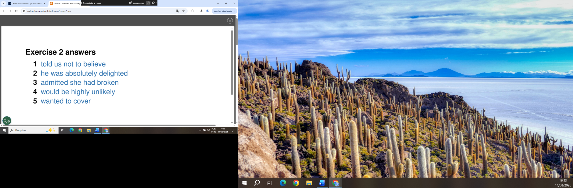

SB - P.117:

1.
2- was listening/ 3- hadn’t liked/ 4- had seen/ 5- wouldn’t

2.
2- told/3- told/ 4- said/ 5- said/ 6- told

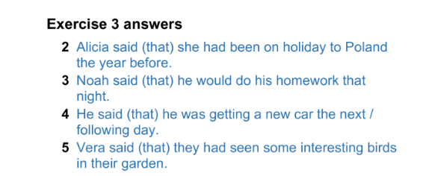
3.

4.
2- admitted/ 3- mentioned/ 4- replied/ 5- stated/ 6- added

5.
2- I asked him if he had forgotten my name.
3- Eva asked Jack if he had finished his homework.
4- Eric’s mum asked him what time he’d arrived home.
5- Pete asked me where I’d been.
6- A Woman asked me what the time was.

6.
2- asked me if I had seen the news.
3- asked me if it had rained the day before.
4- asked me if I was watching a film.
5- asked my mum when my new phone would arrive.
6- asked my dad if it was ten o’clock yet.

7.
2- told us not to feed the animals.
3- asked mum if she could find my t-shirt.
4- told us to watch the cat.
5- told us to go and play football in the park.
6- asked me to make her a drink.

