
CEMP – Centro Educacional Marapendi

Nota:

_______

Nome: ______________________________________________ Data: / /2026
Professor(a): Isabelle 9 º Ano do Ensino Fundamental II Turma: _____

Gabrito homework – Student book, p. 115 e 117

P.115
*Questões 1 a 3 foram corrigidas em aula.

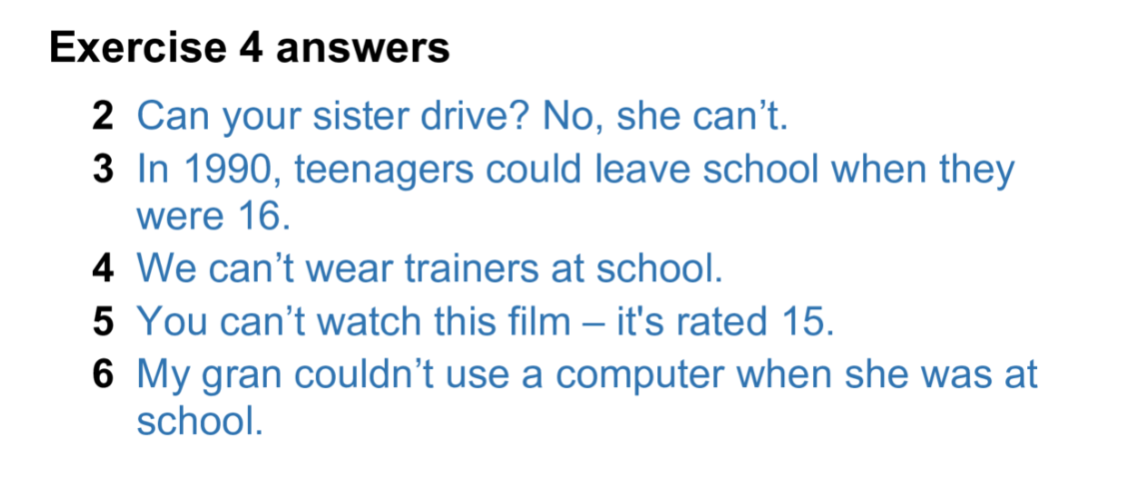
4.

5.
2- more slowly
3- harder
4- worse
5- faster
6- better
7- later
8- more quicly

6.

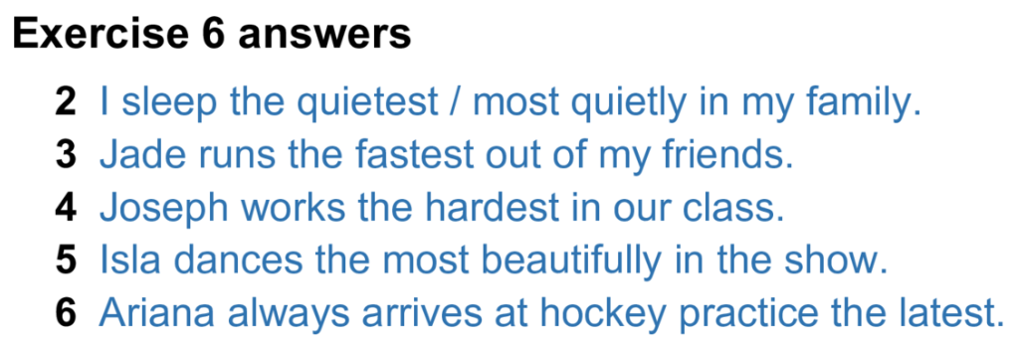
7.
2- more carefully/ 3- better than/ 4- more slowly/ 5- the nearest/ 6-the latest/ 7- the loudest/ 8- more easily

P. 117
1.
2- tried/ 3- won/ 4- run/ 5- found/ 6- writtten/ 7- stopped/ 8- given/ 9- caught/ 10- enoyed/ 11- done/ 12- seen

2.
2- haven’t/ 3- ‘ve given/ 4- Have/ 5- haven’t/ 6- Have/ 7- watched/ 8- haven’t/ 9- you read

3.
2- Have you read this book?
3- We haven’t had a holiday this year.
4- The team haven’t done enoug strenght training.
5- Mandy hasn’t found a job.
6- Who has taken my bike?
7- I haven’t heard the news.
8- He has washed the car.

4.
2- has started/ 3- haven’t worked/ 4- Has_lost/ 5- hasn’t finished/ 6- Have_won

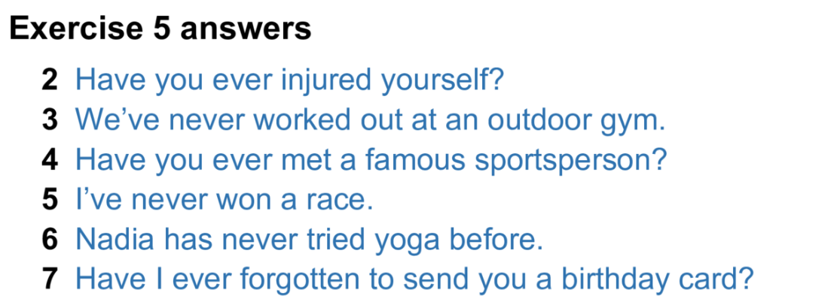
5.

6.
2- Have you ever won any Money?
3- Have you ever seen a lion?
4- Have you ever run 5 km?
5- Have you ever used a fitness app?
6- Have you ever swum 2 km?

7.
2- haven’t/ 3- have/ 4- have you done/ 5- ‘ve been/ 6- haven’t seen/ 7- Have you ever felt/ 8- have/ 9- Have you ever seen/ 10- have happened

